Image | 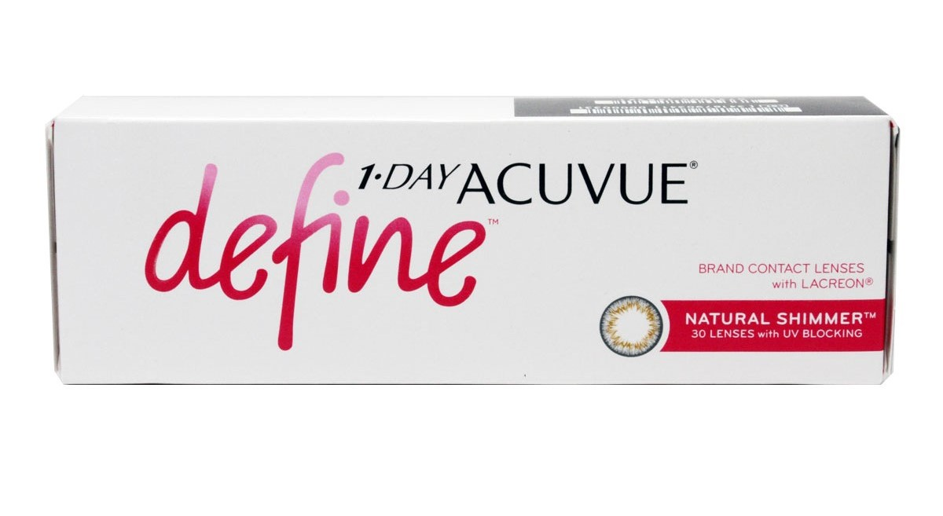
Brand | GUCCI
Model Name | 1-day-acuvue-define
Price | RS 2500
PRODUCT DETAILS

